**Aim: Installation of NS-3, NetAnim and Wireshark in Linux**

**THEORY:**

**Network Simulator:**

Network simulator is a tool used for simulating the real-world network on one computer by writing scripts in C++ or Python. Normally if we want to perform experiments, to see how our network works using various parameters. We don’t have required number of computers and routers for making different topologies. Even if we have these resources, it is very expensive to build such a network for experiment purposes.

So, to overcome these drawbacks we used NS3, which is a discrete event network simulator for Internet.

**Ns-3:**

The ns-3 simulator is a discrete-event network simulator targeted primarily for research and educational use. The ns-3 project, started in 2006, is an open-source project developing ns-3.

NS3 helps to create various virtual nodes (i.e., computers in real life) and with the help of various Helper classes it allows us to install devices, internet stacks, application, etc to our nodes.

Using NS3 we can create PointToPoint, Wireless, CSMA, etc connections between nodes. PointToPoint connection is same as a LAN connected between two computers. Wireless connection is same as WiFi connection between various computers and routers. CSMA connection is same as bus topology between computers. After building connections we try to install NIC to every node to enable network connectivity.

Ns3 gives us special features which can be used for real life integrations.

**Features of Ns-3:**

* 1. **Tracing of the nodes:-** NS3 allows us to trace the routes of the nodes which helps us to know how much data is send or received. Trace files are generated to monitor these activities.
  2. **NetAnim:-** It stands for Network Animator.It is an animated version of how network will look in real and how data will be transferred from one node to other.
  3. **Pcap file:-** NS3 helps to generate pcap file which can be used to get all information of the packets (e.g., Sequence number, Source IP, destination IP, etc). These pcaps can be seen using a software tool known as wireshark.
  4. **gnuPlot:-** GnuPlot is used to plot graphs from the data which we get from trace file of NS3. Gnuplot gives more accurate graph compare to other graph making tools and also it is less complex than other tools.

**NetAnim:**

NetAnim is a stand-alone program which uses the custom trace files generated by the animation interface to graphically display the simulation. NetAnim is based on the multiplatform Qt4 GUI toolkit.

The NetAnim GUI provides play, pause, and record buttons. Play and pause start and stop the simulation. The record button starts a series of screenshots of the animator, which are written to the directory in which the trace file was run. Two slider bars also exist. The top slider provides a “seek” functionality, which allows a user to skip to any moment in the simulation. The bottom slider changes the granularity of the time step for the animation.

Finally, there is a quit button to stop the simulation and quit the animator.

**WireShark:**

Wireshark is an open-source tool for profiling network traffic and analyzing packets.

Such a tool is often referred to as a network analyzer, network protocol analyzer or sniffer.

**Uses of Wireshark:**

* 1. It is used by network security engineers to examine security problems.
  2. It allows the users to watch all the traffic being passed over the network.
  3. It is used by network engineers to troubleshoot network issues.
  4. It also helps to troubleshoot latency issues and malicious activities on your network.
  5. It can also analyze dropped packets.
  6. It helps us to know how all the devices like laptop, mobile phones, desktop, switch, routers, etc., communicate in a local network or the rest of the world.

**Functionality of Wireshark:**

1. Wireshark is similar to tcpdump in networking. Tcpdump is a common packet analyzer which allows the user to display other packets and TCP/IP packets, being transmitted and received over a network attached to the computer. It has a graphic end and some sorting and filtering functions. Wireshark users can see all the traffic passing through the network.
2. Wireshark can also monitor the unicast traffic which is not sent to the network's MAC address interface. But the switch does not pass all the traffic to the port. Hence, the promiscuous mode is not sufficient to see all the traffic. The various network taps or port mirroring is used to extend capture at any point.
3. Port mirroring is a method to monitor network traffic. When it is enabled, the switch sends the copies of all the network packets present at one port to another port.

**Features of Wireshark:**

1. It is multi-platform software, i.e., it can run on Linux, Windows, OS X, FreeBSD, NetBSD, etc.
2. It is a standard three-pane packet browser.
3. It performs deep inspection of the hundreds of protocols.
4. It often involves live analysis, i.e., from the different types of the network like the Ethernet, loopback, etc., we can read live data.
5. It has sort and filter options which makes ease to the user to view the data.
6. It is also useful in VoIP analysis.
7. It can also capture raw USB traffic.

**Steps for Installation:**

**1. Prerequisites:**

sudo apt upgrade

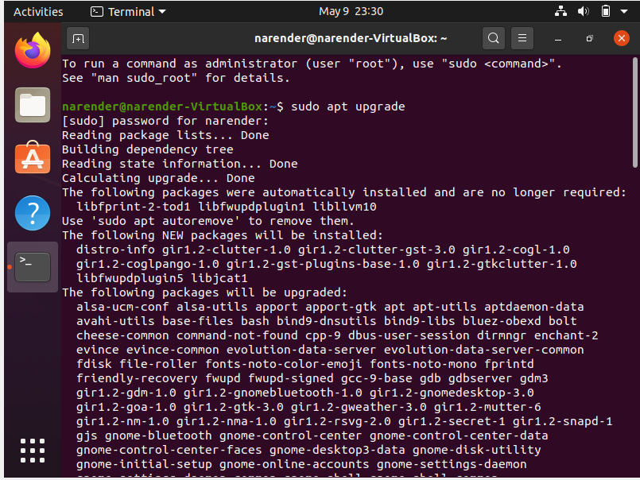

sudo apt update

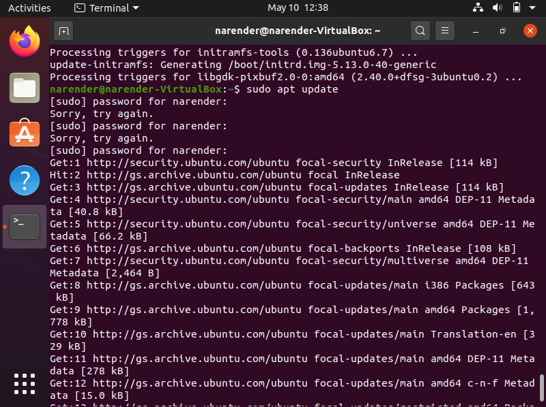

**2. Minimal requirements for Python API users**

sudo apt-get install g++ python3 python3-dev pkg-config sqlite3

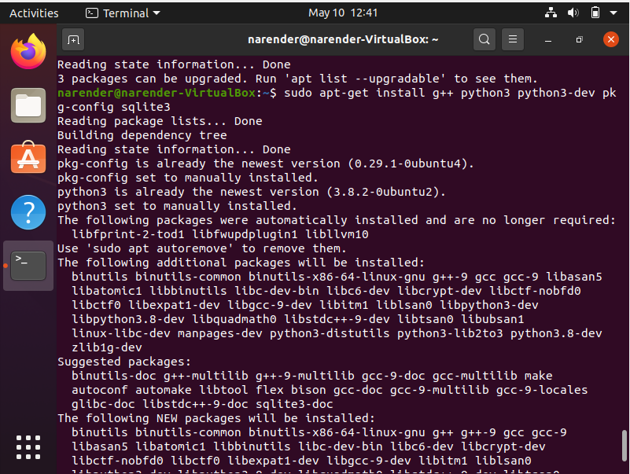

**3. qt5 development tools are needed for Netanim animator:**

sudo apt-get install qt5-default mercurial

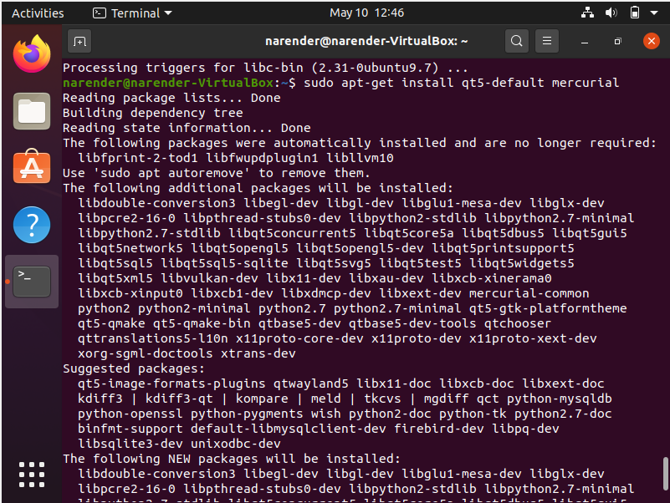

**4. ns-3-pyviz visualizer:**

sudo apt-get install gir1.2-goocanvas-2.0 python3-gi python3-gi-cairo python3pygraphviz gir1.2-gtk-3.0 ipython ipython3

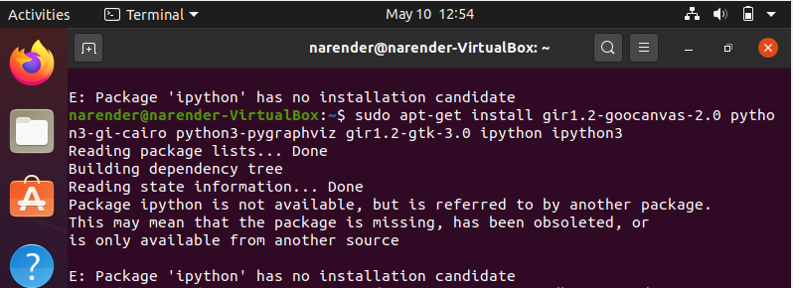

**5. Debugging:**

sudo apt-get install gdb valgrind

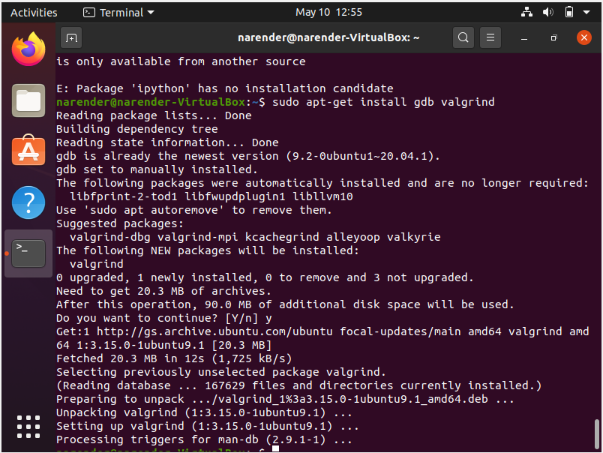

**6. Doxygen and related inline documentation:**

sudo apt-get install doxygen graphviz imagemagick

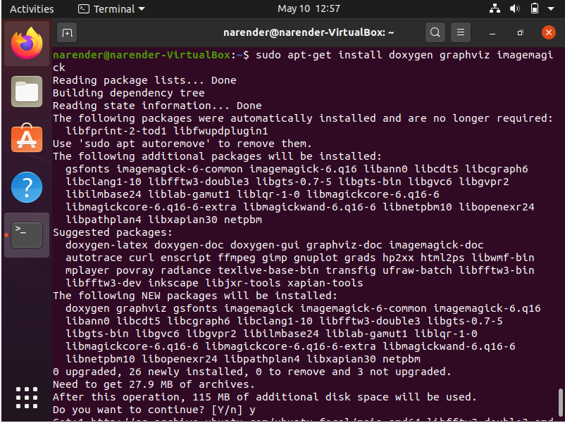

sudo apt-get install texlive texlive-extra-utils texlive-latex-extra texlive-font-utils dvipng latexmk

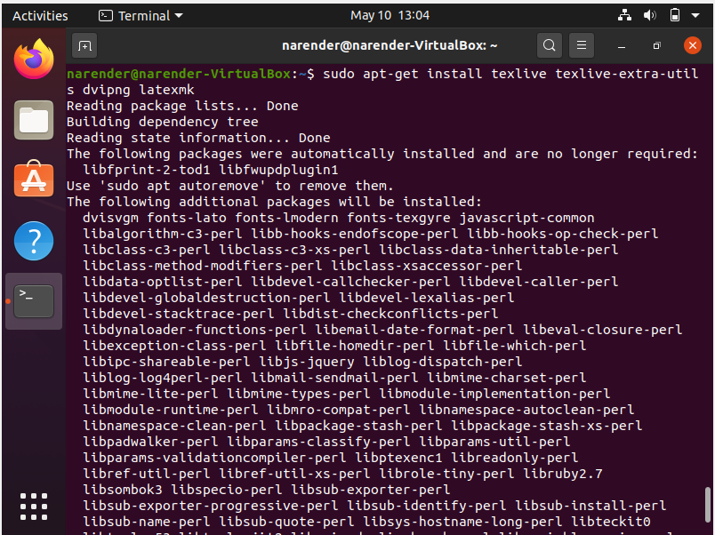

**7. The ns-3 manual and tutorial are written in reStructuredText for Sphinx (doc/tutorial, doc/manual, doc/models), and figures typically in dia (also needs the texlive packages above):**

sudo apt-get install python3-sphinx dia

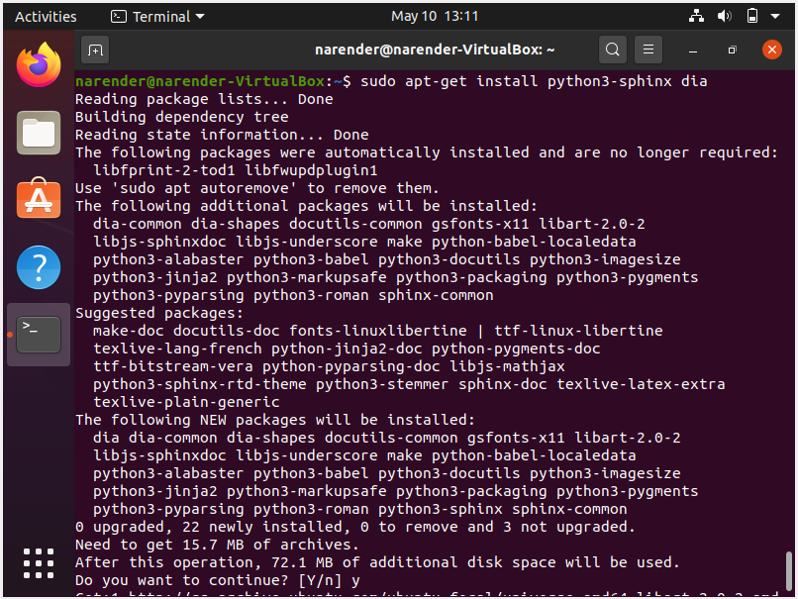

**8. To read pcap packet traces:**

sudo apt-get install tcpdump

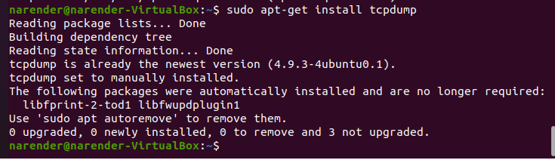

**9. Support for generating modified python bindings:**

sudo apt-get install cmake libc6-dev libc6-dev-i386 libclang-6.0- dev llvm-6.0-dev automake python3-pip

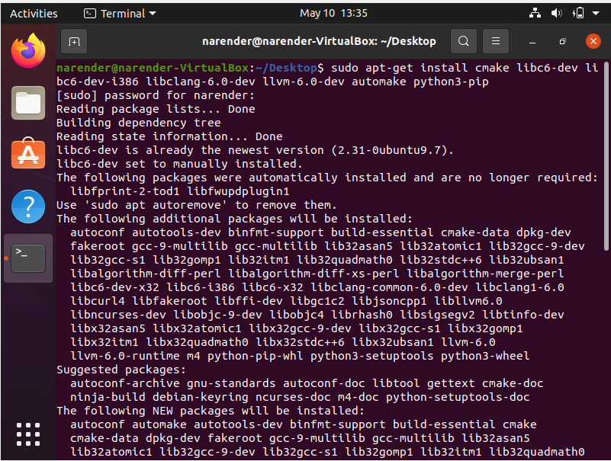

python3 -m pip install --user cxxfilt

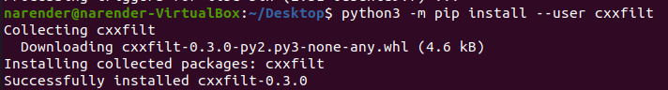

**10. ns-3 Build and test:**

Go to ns-3.33 folder

cd workspace/ ns-allinone-3.33/

./build.py --enable-examples –enable-tests

wget -c https://www.nsnam.org/releases/ns-allinone-3.33.tar.bz2

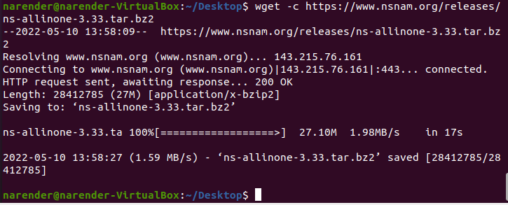

tar -xvjf ns-allinone-3.33.tar.bz2

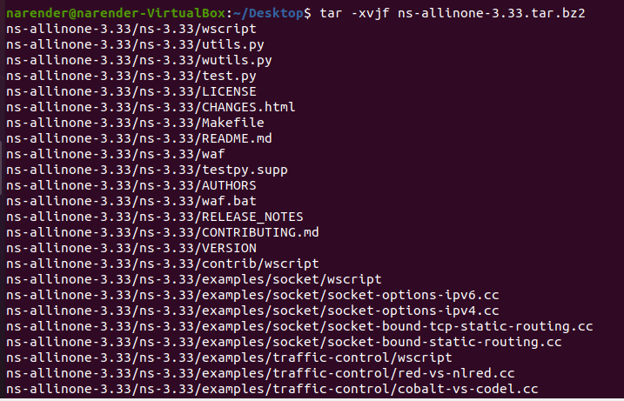

cd ns-allinone-3.33/ns-3.33/



*# Configure the installation*

./waf configure --enable-examples

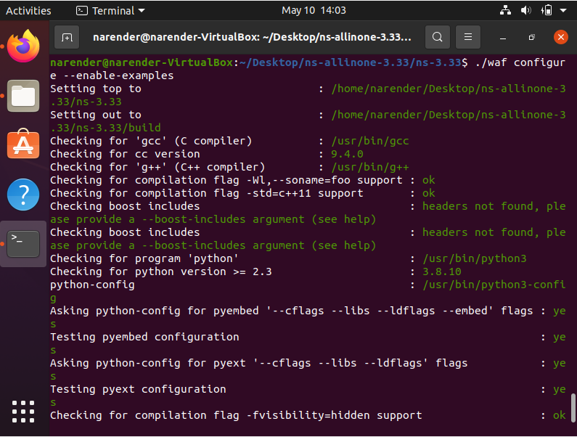

*# Build ns-3 installation*

./waf

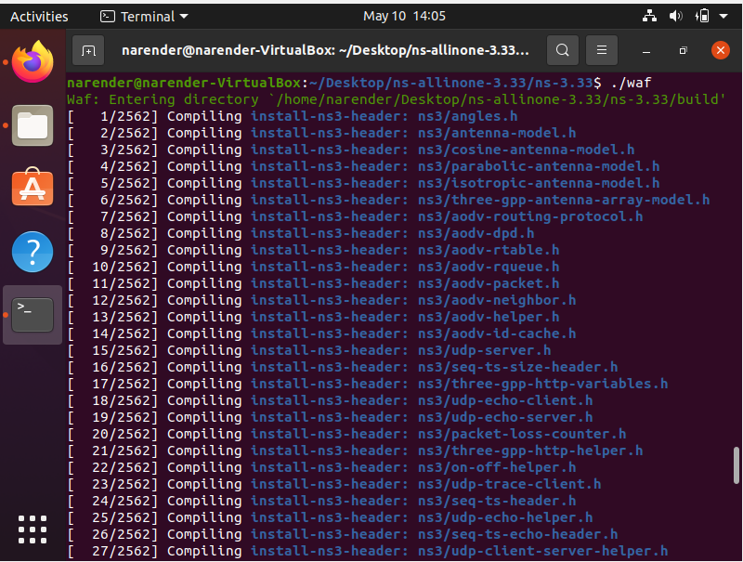

*# to check whether installation was a success*

./waf --run hello-simulator

*# navigate to netanim dir.*

cd ns-allinone-3.33/netanim-3.108/

*# configure the build*

make clean

*# compile the build*

qmake NetAnim.pro

*# build netanim installation*

make

*# to execute NetAnim*

./NetAnim

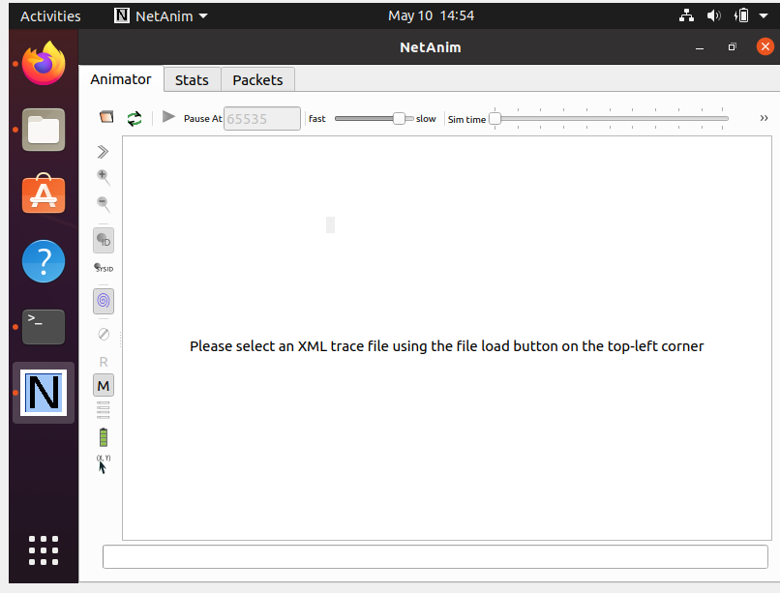

1. **Test the NS3 build and installation success by running test.py in the ns directory using the following commands:**

cd workspace/ ns-allinone-3.33/ ns-3.33

./test.py

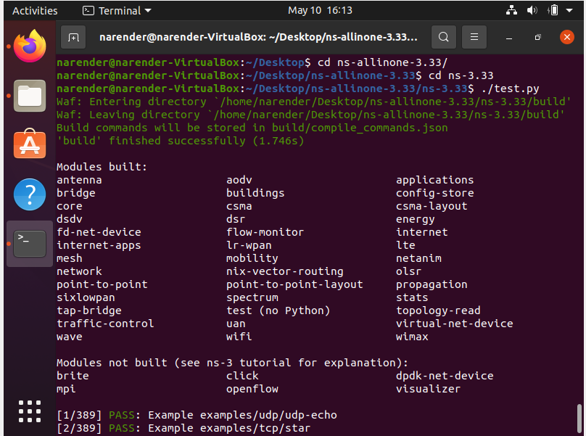

1. **Install WireShark**

sudo apt-get install wireshark

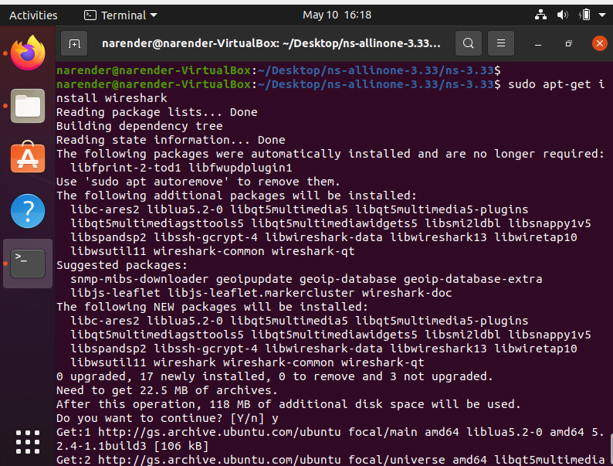

**Conclusion:**

From this practical, I have Successfully installed Ns-3, NetAnim and WireShark.